# Project Overview

## Desktop Site

Audience

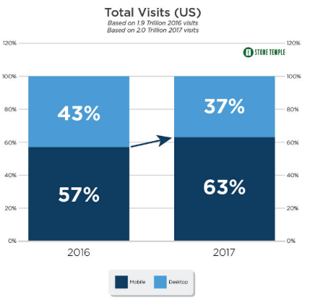When we look at Desktop vs Mobile, we look at the most important variables which influences the viewers who would view our website on Mobile and Desktop. Firstly, let’s look at the benefits in using mobile devices to access the website.

* It is helpful on the move during the event
* Nowadays people primarily use their mobile devices
* It is easier to access your mobile compared to your desktop

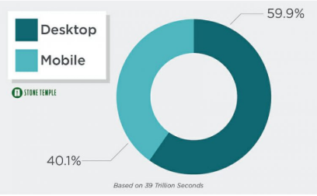All three points are valid, however in many events such the Human Rights Arts and Film Festival, there will be pamphlets that will be handed out, thus you won’t even need to utilize your mobile device for navigation purposes.

We researched the retention time of viewers staying on a website before clicking out and is known that website users beat mobile users in this element. This statistic is very important as the HRAFF website is designed to display events, films so that viewers will be interested and buy their tickets. With a shorter retention time, this less likely fulfills the needs of what the website is designed for.

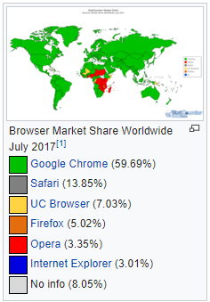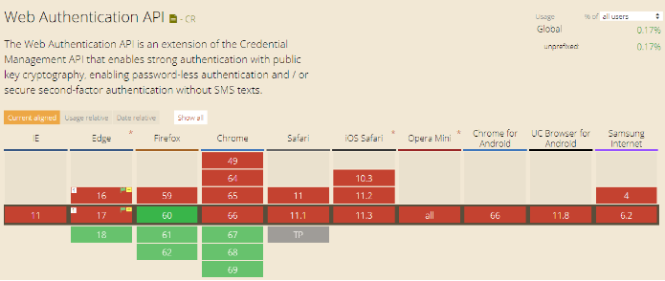Creativity Limitations

To please a user’s experience, it is best to create a unique website style that will want the user to re-visit. In a study, Sarah researched about the differences between all interfaces, mobile and desktop. There shows a trend where Edge, Firefox, Chrome and Safari all can use the ‘Web Authentication API’, however the mobile devices lack the resources to cope with this functionality. If mobile users must access the HRAFF website, mobile users may suffer a disadvantage when using certain tools.



Another way to make a user experience more memorable, is by adding responsive techniques or animations to convey the website’s desires. Phones have a bad time with animations as it requires your phone to intensively use the processor whilst simultaneously drains the phone’s battery. This limits creativity to many designs as you are essentially trading creativity for efficiency.

Clarity

Overall, we believe we can express our design more thoroughly in a desktop design. We would be able to provide more examples, spread out content evenly and make scrolling less cumbersome for users. Also, in a website where there are lot of categories to look through, the hamburger menu, although a good substitution for the navigation bar, having a lot of hyperlinks displayed in a row will dissuade the user from using it.

## Page Types

Pages for the HRAFF website

* The home page of the website
* A page that lists all the festival’s events
* A page that gives detail about one specific even

To inspire the HRAFF company in choosing our design, we strongly believe by showing all the important pages, it creates a sense of notion that we truly care about the design and would be honored to be chosen and then featured as the HRAFF website for 2019.

Pages using standards of WordPress

* Single Post or Single Page
* Post Archive or Search Results
* 4~~04 Error Page~~

We felt an error page was not necessary to create, due to the reason that the HRAFF organization will not care about the design of an error page but instead the functionality and how the website interacts.

## Teamwork tools to help solve the problems

Problems

**Comes with a steep learning curve**

The more time we spend learning about WordPress, the less time we spend on implementing our website. With certain goals that require functionality that we are unfamiliar with, we may need to discard some functionality that prove to be too difficult in a short amount of time. To be able to utilise advanced customization options, having a strong understanding of different code languages is necessary.

**Data Corruption**

Wordpress does not have a backup server that saves our progress and will not have a way to rollback to a working version. Although not common, is a major risk we must consider as hours of work will be lost if we do not find a solution to backup our work.

**Error messages**

As we are new to Wordpress, it will be natural to find errors when implementing our website. But, it is known that wordpress has a ‘white screen of death’ which does not give you an explanation as to what error you are having and can be annoying and unefficient in discovering the bug.

**Customisation**

There are over 40,000 plugins that we can use! However, most of the plugins requires you to pay a steep price to be able to license them. This limits our exploration with most of the plugins, especially in cases where some plugins do virtually the same thing and finding the right plugin for you can be an adventure.

**Page Speed**

This is something that is unavoidable and something we have to deal with when tinkering around with Wordpress. The main problem that we will experience is that the more plugins we implement, the slower the page will load and appear. We have to be as efficient as possible which indirectly increases our work efficiency and bug finding. Also another aspect to consider is that nowadays, Google uses page speed in their rank algorithm, thus for users that search results relates to “Arts and Film”, we would want the HRAFF website to join the front page section on the Google search results.



GitHub:

We have been using Github to share files for nearly 3 years now and are both experienced and happy to reuse this software to save and share data towards one another.

We initally thought this would be a good way to backup the wordpress files and revert changes if needed. After working with WordPress, we noticed that the files exceeded the GitHub file size and thus resorted in saving our work locally. Although GitHub is not being utilised to the fullest, sharing the documents and the presentation slides was efficient in completing the tasks without updating each other on what we have completed.

Nevertheless, Github is a great way to check progress on work that we share together.

Trello:

As we have used Trello for Assignment 2, we will again continue to use this process tool as it acts as a contract on work that is needed to be completed from one another. Listing all tasks before having a clear idea in how to divide the tasks evenly between each other.

Meetings:



Due to our GitHub failing to share the WordPress files, we decided to meet in person to discuss tasks and potential flaws our website might produce. By talking in person, it will be easier to show and explain our progress and concerns which will require a longer discussion.

# Research and Conceptual Development

## Inspiration of Design Ideas

We will continue to utilize Matt’s website and further develop the other pages which includes the festival list page and their individual events page.

The reason being, Matt’s prototype from Assignment One is more polished compared to Kelvin’s and less flaws were present such as consistency. We looked at the pros and cons for both website and agreed on it unanimously.

Kelvin’s Homepage Website:

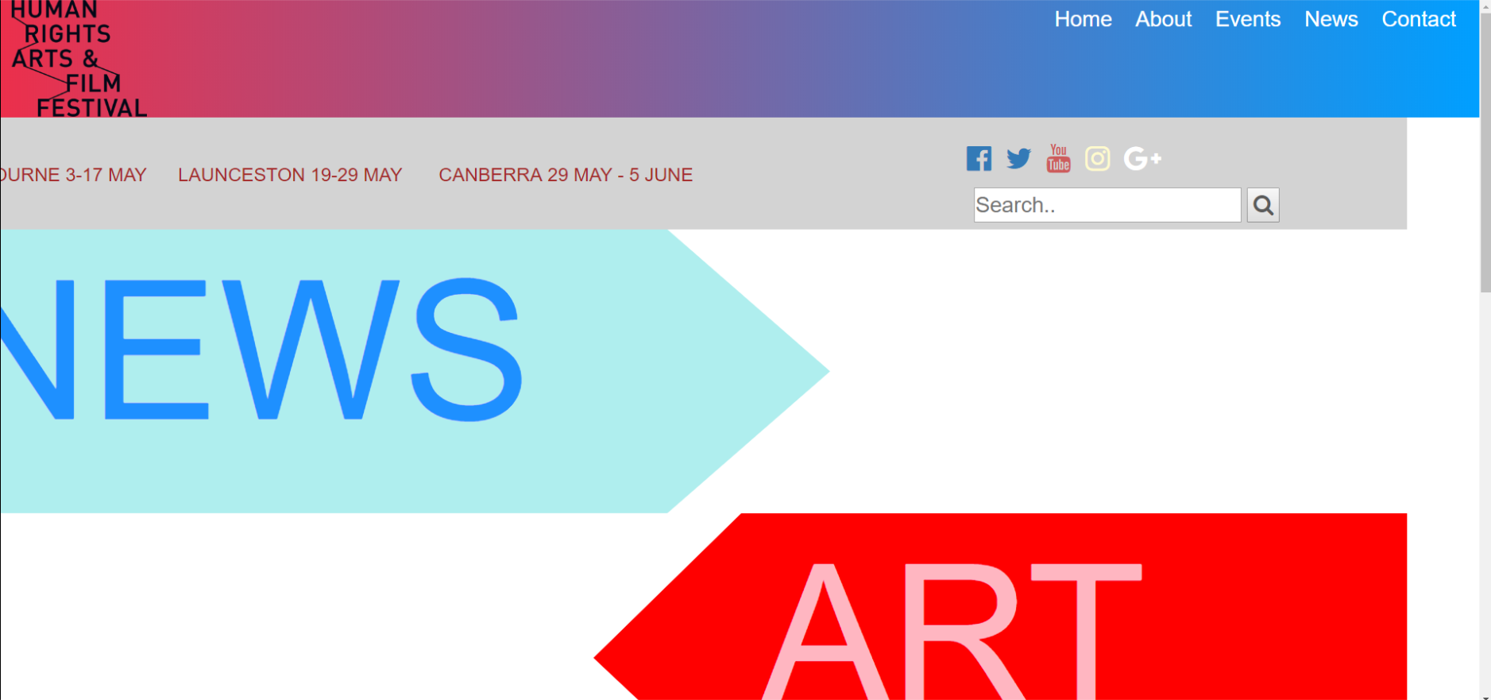

Pros:

* Creative ways to display data
* Modals are great way for viewers to click in and out without the back button
* Implements responsive categories to not clog up the website with examples.

Cons:

* Color contrast was weak and basic
* Is not a modern look
* Not a suitable way to attract the audience
* Modals only pop up one example for each category.

Matt’s Homepage Website:

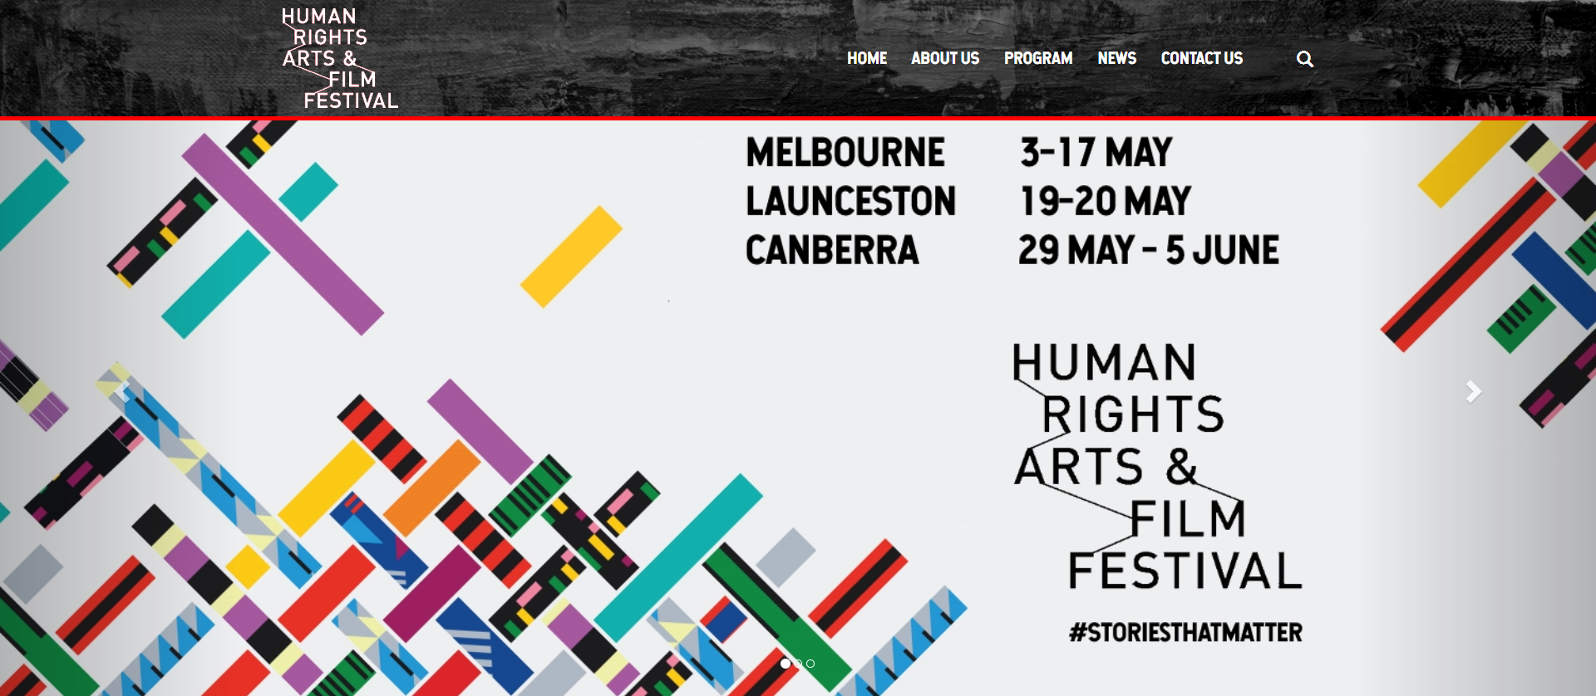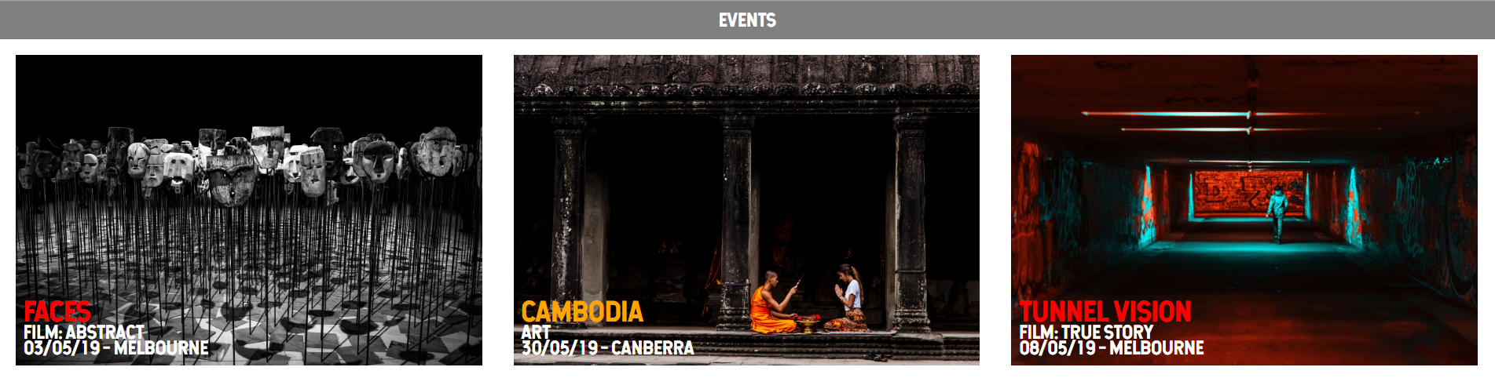

Pros:

* Elements are all well aligned
* Includes a carousel method which helps with displaying multiple ads
* Includes a lot of responsive animations
* Navigation bar is responsive when scrolling
* Incorporates YouTube videos to be playable on the website

Cons:

* Dark red doesn’t fit well with the art and film festival theme
* Hovering on elements that fade red although is consistent, makes the elements harder to see.

The most significant difference is that Kelvin’s website uses a modal type style which will not draw the viewers in but instead make the website easier to access certain categories viewers would want to see. Due to the nature of the HRAFF organization wanting to sell tickets for profit and viewership, it is also in our best interest to use a style which facilitates this requirement.

Thus, we both strongly agreed on Matt’s homepage to be the heart of our website and draw elements so that the theme is similar in all our pages.

## Research

As we will fully utilize Matt’s Homepage website, our research will focus on mainly usability and scaling aspects.

**Branding Elements**

Font Text: Hansief and Roboto

We will be retaining most of the same branding design, the main changes with the design will be usability and scaling aspects

Mainly greyscale colour scheme with highlights in bright colours, aesthetically pleasing to users

Grey paint texture for the navigation bar, authentic feeling

Fonts: ‘Hansief’ for headings, ‘Roboto’ for body

**Shneiderman’s 8 Golden Rules**

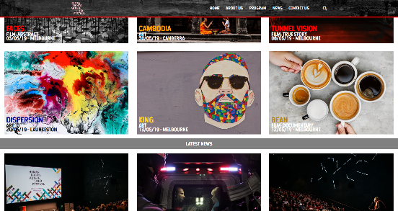We looked at Shneiderman’s rules and took these elements into consideration

1. Strive for consistency.

* Grid structure and spacing
* Consistent typeface and colour scheme

1. Seek universal usability.

* Increasing the size of navigation and sub-headings from the original design
* The magnifying glass implies to all users that there is a search option
* Clicking on the logo reverts you back to the homepage.

1. Offer informative feedback.

* Implemented a subscriber tool so users can receive information about the event if they choose to subscribe.
* Nearly all elements are responsive when hovered, allowing users to understand what can be clicked.

1. Design dialogs to yield closure.

* Has a beginning, middle and end so that users can scroll down without getting confused.
* Beginning: The images, the navigation bar.
* Middle: The examples of the news, event and film categories.
* End: Subscriber tool, ads, the social media links.

1. Prevent errors.

* Follow standard protocols to eliminate code smells which includes uses of id’s, classes and div’s.
* Insert validation to prevent SQL injection and other methods that tries to break into unauthorized authentication.

1. Permit easy reversal of actions.

* Implement breadcrumb trail on the left-hand side of the screen so the user can go back to the previous page at any time.

1. Keep users in control.

* Show relevant information relating to the categories to not mislead the users.
* Don’t display pop ups which can annoy the user and click out of the website.

1. Reduce short-term memory load.

* Ensure our database follows a structure where data can be easily manipulated without many dependencies.

**Norman’s 7 Principles**

We also looked at Norman’s 7 Principles to make sure our interactive design does not dismay the users.

1. Discoverability/Visibility

* Carousel should be reduced in height so that the page elements below are more visible to users upon initial glance.

1. Feedback

* When hovering on the examples, the image elements will zoom in slightly, but the text remains static as the text is more important compared to the images.

1. Conceptual Model Consistency

* Page navigation is in the expected location, in the top bar.

1. Affordance

* Nearly all interactive element will have some type of cue signaling the users to be able to click on the elements.

1. Signifiers

* Arrows for navigating carousel will be made larger so they are easier to see.

1. Natural Mappings

* For the images that is in a carousel element, the arrows on both sides indicate visibility to the previous or next image. The breadcrumb trail will also be on the left-hand side which indicates to the users that clicking there will prompt them to go back to their previous page.

1. Constraints

* Using WordPress, the more plugins we implement for interactive purposes, the slower the page loads.

## Inspiration

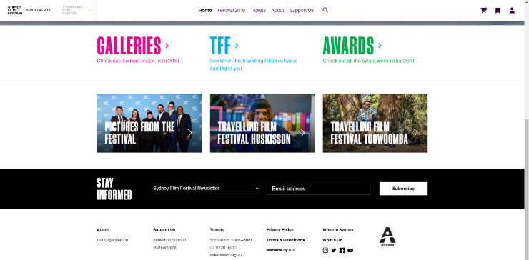

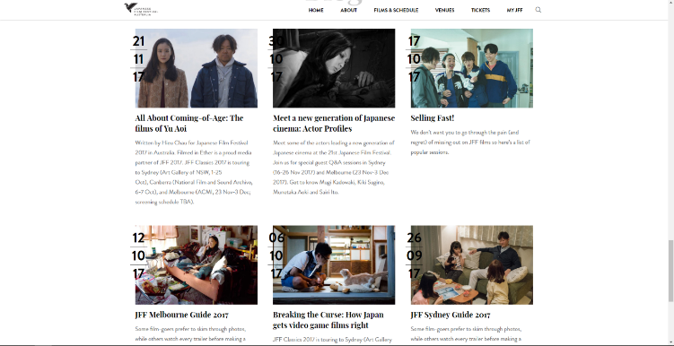

The grid images above contain text which is a great way to display information. Not only does it save space in our website to add more examples/elements, it shows concise and condensed information of what the viewer will need to know about that element. On the right image you see that there is a lot of text beneath the grid elements which makes the website look unorganized as humans prefer symmetrical visualization.

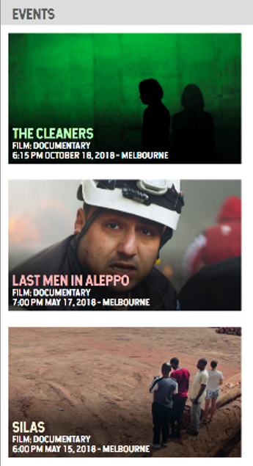

Here, our design reflects our research and in addition added in color for the title to improve overall contrast and clarity. The title is the most important text for viewers to see as they will click on the event’s page fundamentally based on the unique title and thumbnail.

# Content Management Architecture

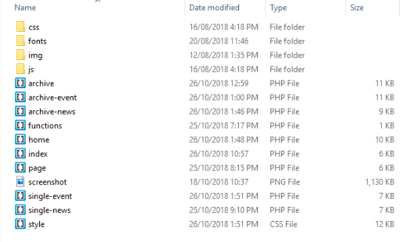

**Analyze the content management structure requirements for storing event data effectively.**

We have adopted a similar template to the image to the right. Using the eye test, it is easy for any individual to notice the structure of the website and edit sections in the website for solving bugs and updating changes.

We decided that every page should include the navigation bar, ads, social media links and the subscriber tool which will define our website structure.

**Index.php**

Template default page from WordPress. We won’t be using this page to run our site.

**Archive**

Uses custom posts to sort and filters the events and news gallery pages. You can filter by ‘City’ and sort by newest and oldest.

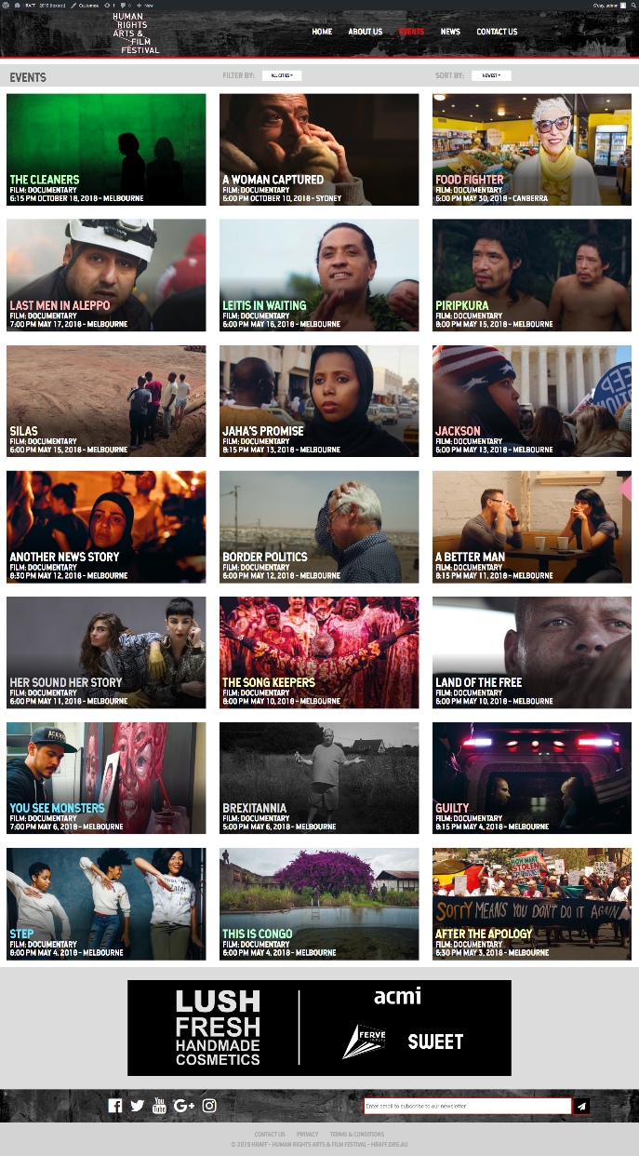**Archive-event.php**

The gallery of the events page, which contains all the examples of the events.

* Title
* Filter and sort
* Events Examples
* Ads
* Social Media icons
* Self-subscriber tool

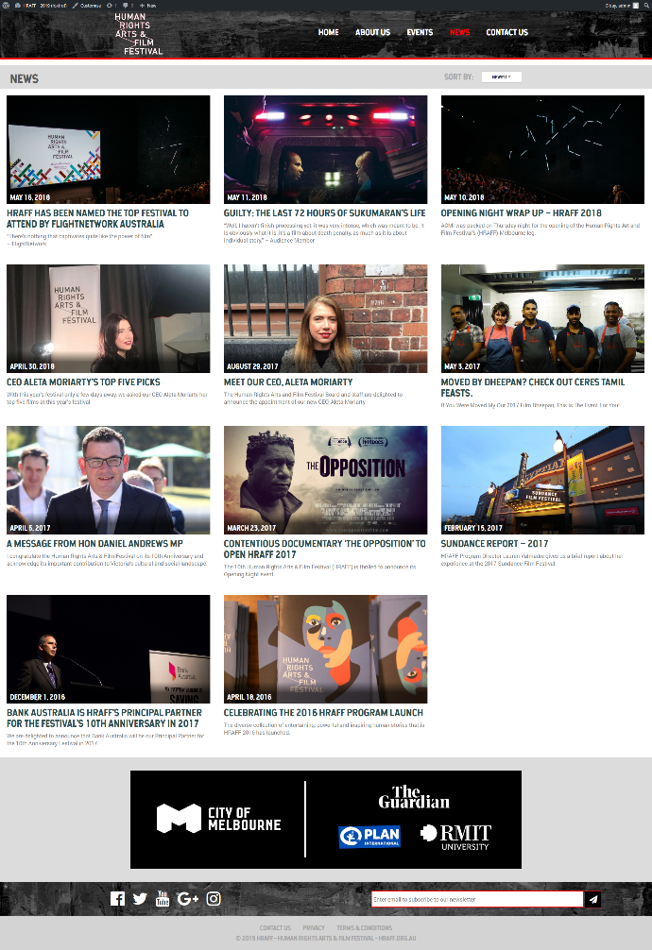

**Archive-news.php**

The gallery of the news page, which contains all the examples of the news.

* Title
* Sort
* News Examples
* Ads
* Social Media icons
* Self-subscriber tool

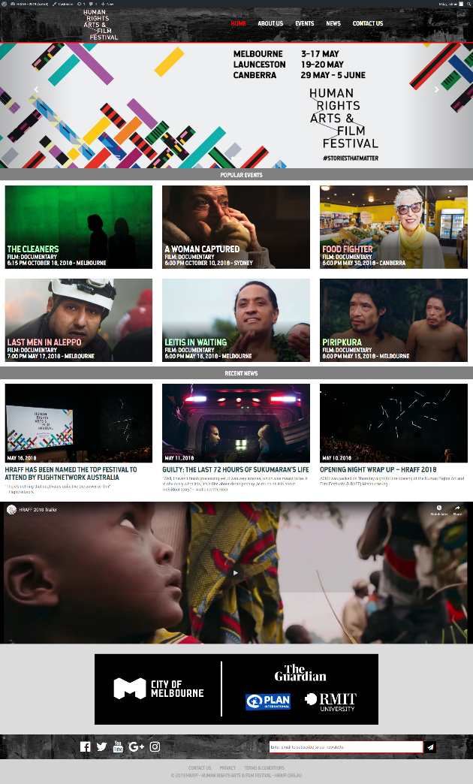

**Home.php**

The homepage of our website.

* Navigation bar
* Carousel of images
* Some popular events
* HRAFF YouTube Video
* Ads
* Social Media icons
* Self-subscriber tool

**Page.php**

This page acts as a filler for the “Contact us” and “About us” as these pages were not required in the requirements.

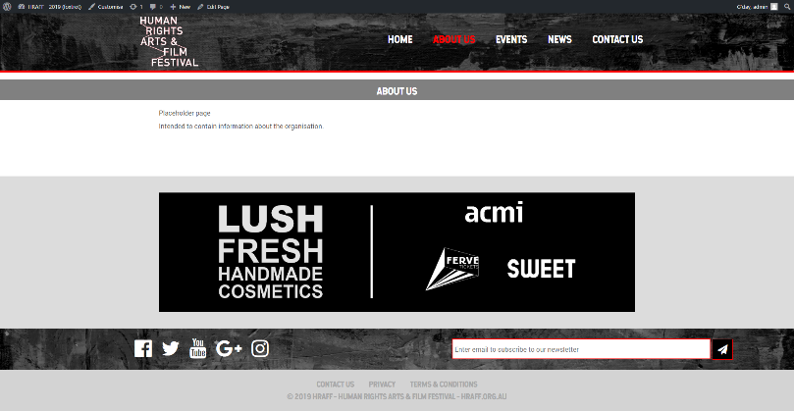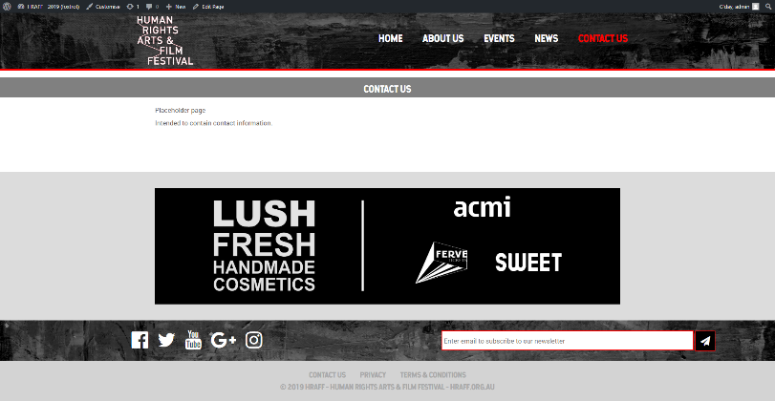

* Title
* Placeholder page
* Ads
* Social Media icons
* Self-subscriber tool

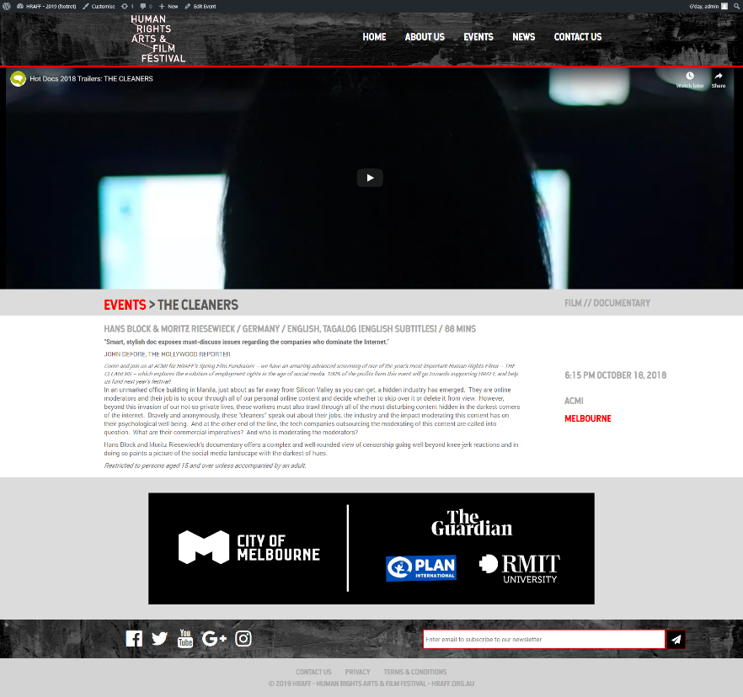

**Single-event.php**

A specific event page’s template

* Navigation Bar
* Video/Image, whichever is available
* Title
* Genre
* Text
* Date and time
* Place
* Ads
* Social media links
* Subscriber Tool

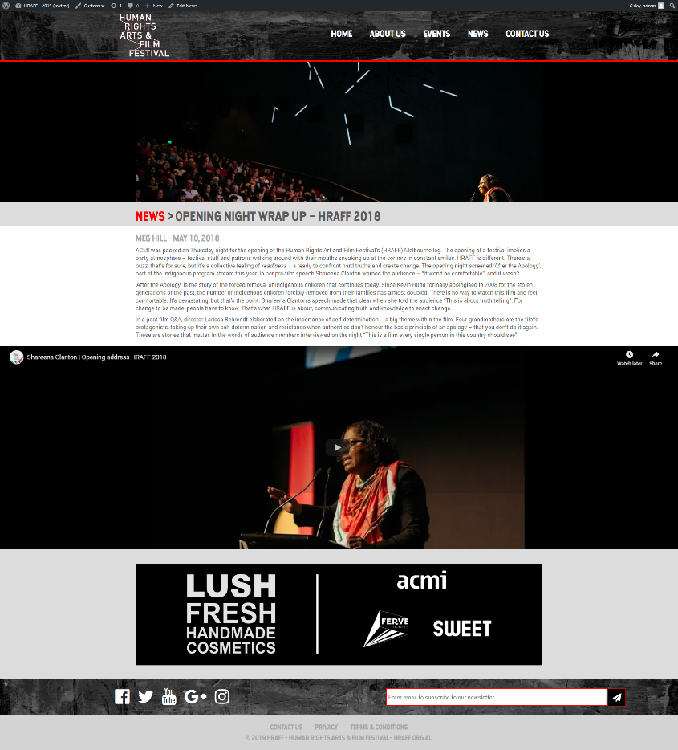

**Single-news.php**

A specific news page’s template

* Image
* Title
* Date, time, place
* Text
* YouTube link if available
* Ads
* Social media links
* Subscriber Tool

**Functions.php**

The functions required for our plugins to work in WordPress.

**Style.css**

The style of the site. Includes color, padding, margins, grids and primarily the position of the elements.

**Describe how custom post types, taxonomies and fields can be used in WordPress to aid information entry and storage.**

WordPress provides custom post types, taxonomies and fields that can be used to order our page structure from top to bottom. We could also add custom fields such as YouTube links that have not been provided by WordPress.

**Standard Posts**

* Posts contain information including title/headline, author, category, tags and summary
* Collated in chronological order
* Will be useful for the news article posts because they do not require information additional to the standard post type

**Custom Post Types**

* Allows the developer to modify a large range of options for the posts
* It would be suitable for events posts which have more data requirements than the standard posts allow for
* Additional requirements include
  + Location
  + Date & Time
  + Dress code
  + Price
  + Awards

**Custom Taxonomies**

* Will allow the news article posts to be searched by parameters in the form of a user defined category
* Offers a more detailed level of classification than the default taxonomies
* Custom taxonomies can be created for the news article and event posts to improve accuracy of sorting and grouping on the parent page

**Custom Fields**

* Metadata which allows the addition of post/page related information
* Will be used in the website for attaching custom fields to the event posts but they are not essential to the working functionality
* This will be beneficial for setting an expiry date for the event posts, they can be hidden from view to users after a certain time period prior to the event occurrence

# References

Mobile vs Desktop Usage in 2018: Mobile takes the lead

<https://www.stonetemple.com/mobile-vs-desktop-usage-study/>

Mobile vs Desktop Usage: Mobile Grows But Desktop Still a Big Player in 2017

<https://www.stonetemple.com/mobile-vs-desktop-usage-mobile-grows-but-desktop-still-a-big-player-in-2017/>

5 Pros and Cons of the Mobile Desktop

<https://readwrite.com/2011/05/05/5-pros-and-cons-to-the-mobile-desktop/>

How to make a cross browser compatible website

<https://medium.com/@sarahelson81/how-to-make-a-cross-browser-compatible-website-40796eaeda05>

Usage share of web browsers

<https://en.wikipedia.org/wiki/Usage_share_of_web_browsers>

Using animation to improve Mobile App User Experience

<https://www.shopify.com.au/partners/blog/using-animation-to-improve-mobile-app-user-experience>

8 of the Most Annoying Problems with WordPress

<https://www.impactbnd.com/blog/problems-with-wordpress>

Ben Shneiderman’s 8 Golden Rules

<https://www.cs.umd.edu/users/ben/goldenrules.html>

Norman, D. (2013). *The design of everyday things*. New York: Basic Books.

The Complete Guide to Custom Post Types

<https://www.smashingmagazine.com/2012/11/complete-guide-custom-post-types/>

WordPress Post Types

<https://codex.wordpress.org/Post_Types>

When do you need a custom post type or taxonomy in WordPress?

<https://www.wpbeginner.com/beginners-guide/when-do-you-need-a-custom-post-type-or-taxonomy-in-wordpress/>

WordPress Custom Fields: 101 Tips, Tricks and Hacks

<https://www.wpbeginner.com/wp-tutorials/wordpress-custom-fields-101-tips-tricks-and-hacks/>

Assignment Brief

<https://moodle.vle.monash.edu/pluginfile.php/7466736/mod_resource/content/1/Presentation%203.pdf>